GOOGLE SHEETS AS LIGHT DATABASE

# H

## ADVANTAGES OF GOOGLE SHEETS AS DB

1. Stores structured data
2. Edit and Delete data easily
3. Online Data Access

## DEMERITS

1. Number of cells capped to 10 million
2. API calls per minute

# APPROACH

## Enable APIs

Steps

1. **Creating a new project**

Go to <https://script.google.com/home/all>

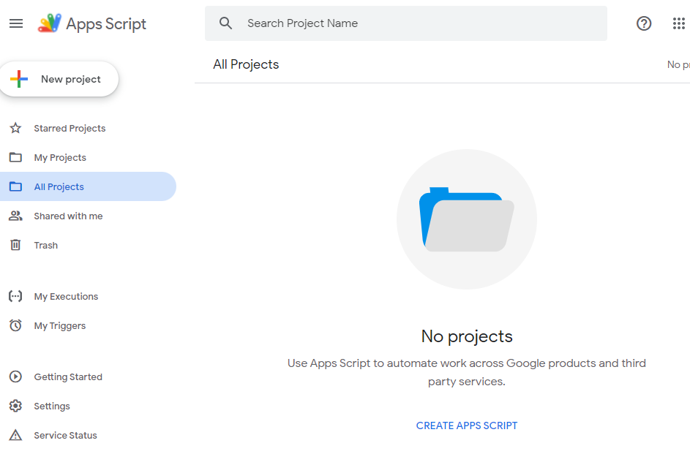

Figure showing the Apps Script from <https://script.google.com/home/all>

Go to console.google.com

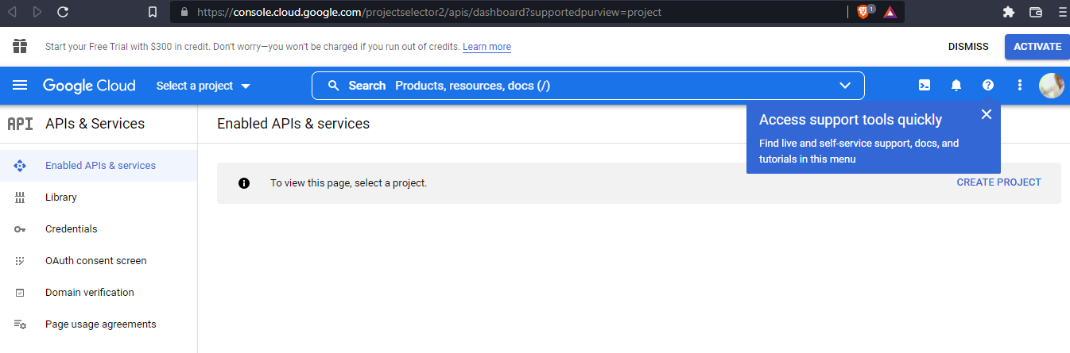

Figure showing creating a new project from <https://console.cloud.google.com/>

Create a new project

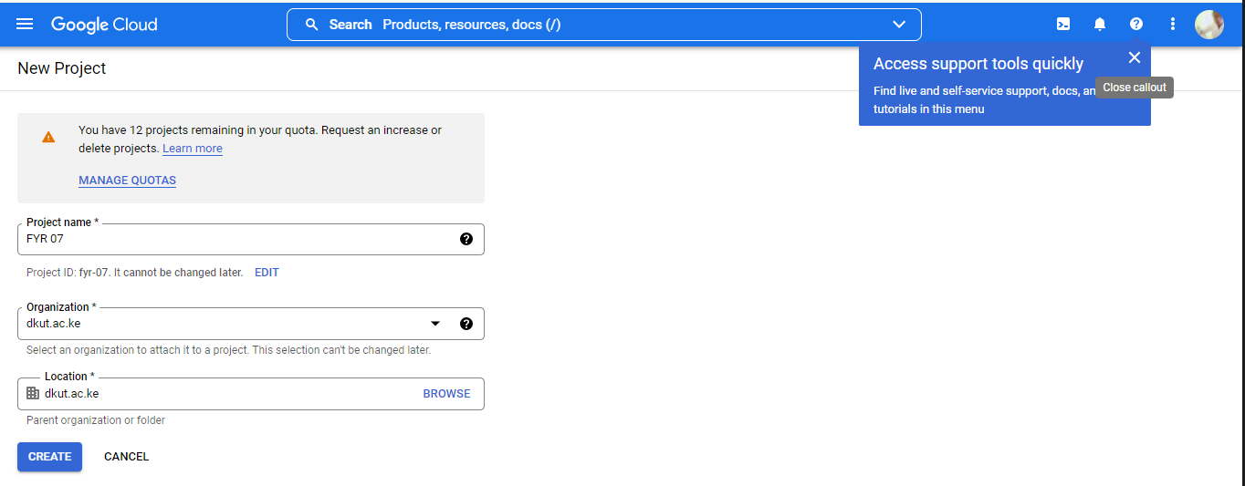

*Figure showing: A domain name entered with creating a new project*

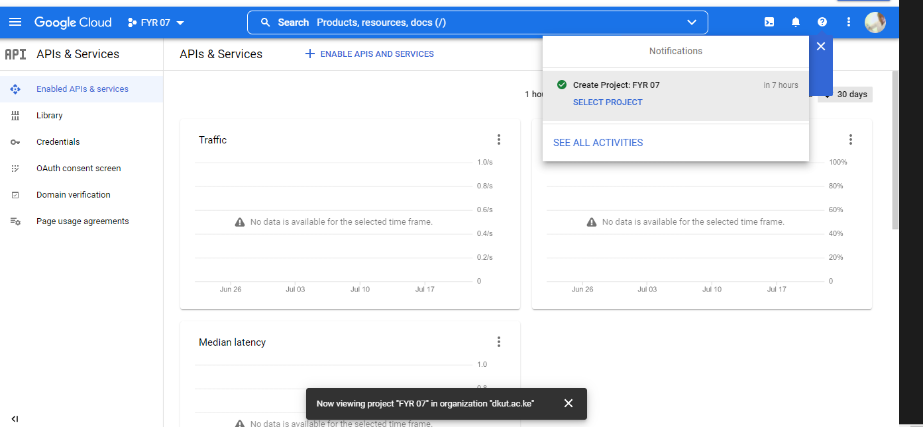

*Figure showing the active project details after creating it from console.google.com*

Go to enabled API and search Sheets API – Google Spreadsheets

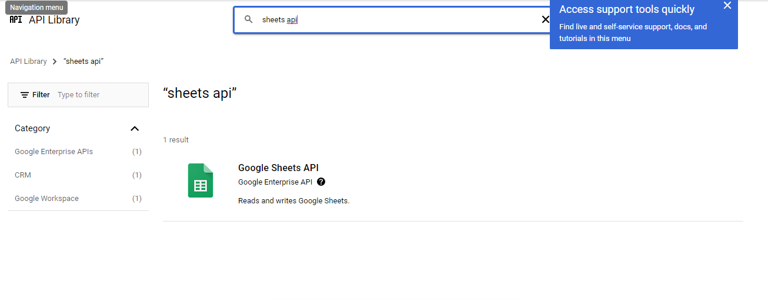

*Figure showing the SHEETS API from console.google.com*

Click Enable API under Sheets API to create credentials.

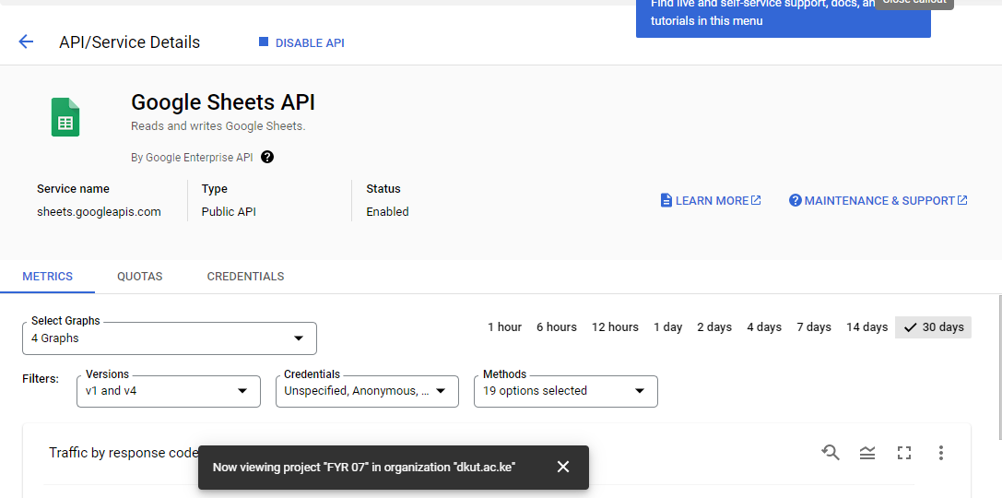

Figure showing the credentials after enabling SHEETs API

Configure the Credentials (if necessary) to support Unspecified, Anonymous or Google Cloud Console API Key- This applies to either API Keys, OAUTH clients or Service Accounts respectively.

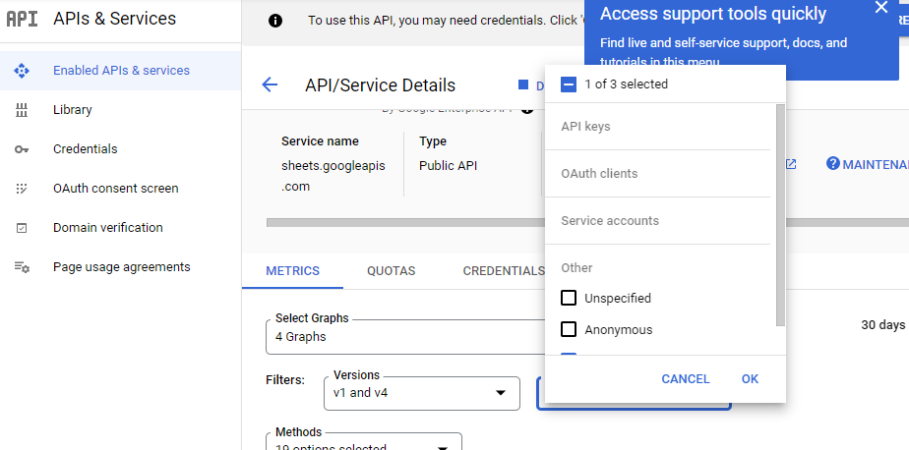

Create Credentials to get started

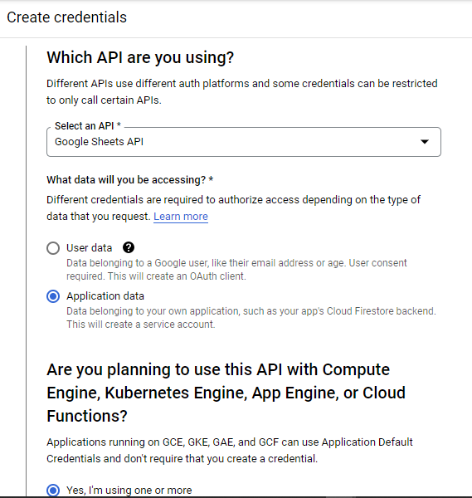

*Figure showing the credentials menu.*

Add KEY from the service account

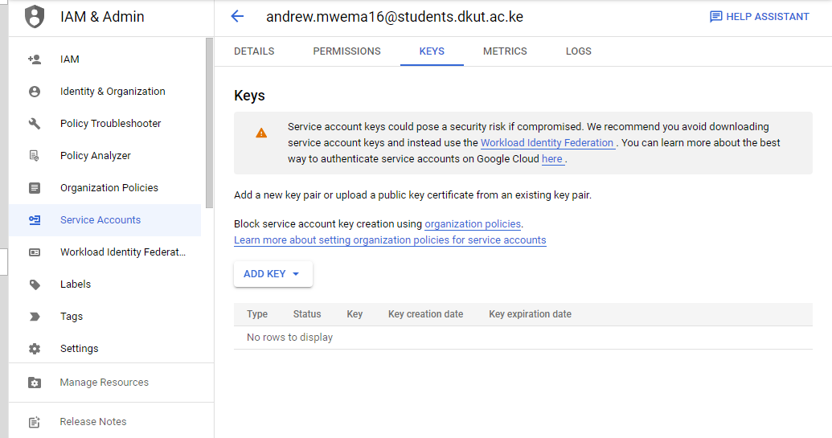

*Figure showing the KEY menu from the service account*.

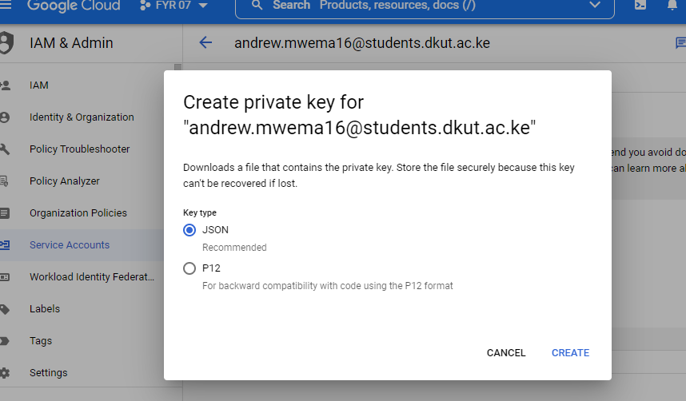

*Figure showing the private key generation as a JSON file*.

1. **Downloading credentials in JSON file**

Go to Developers Console and follow the steps outlined below

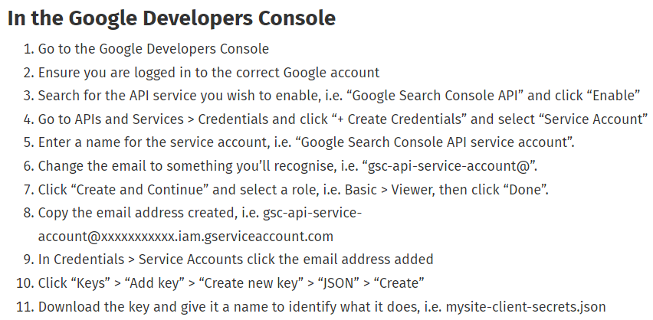

1. **Creating a new project**

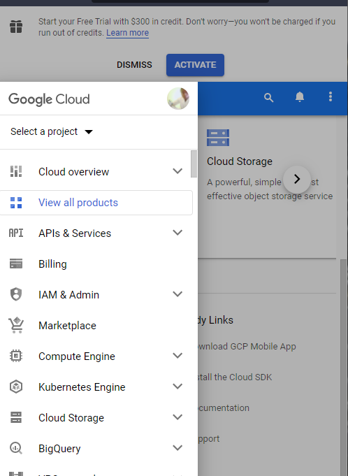

*Figure showing the Console Google Cloud Storage*

## Turning Google Sheets to Database

### Connecting to Google Sheets

Installing the required Libraries

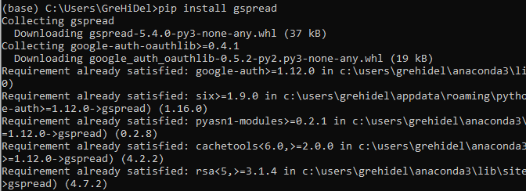

*Python pip install gspread*

### Creating Blank Spreadsheets

### Sharing Link to spreadsheets

### Opening and Uploading Sheets

# REFERENCES

1. Generating Secrets JSON File. Google Developers. <https://practicaldatascience.co.uk/data-engineering/how-to-create-a-google-service-account-client-secrets-json-key>
2. Candlestick Pattern: <https://en.wikipedia.org/wiki/Candlestick_pattern>